LLM Trace Count

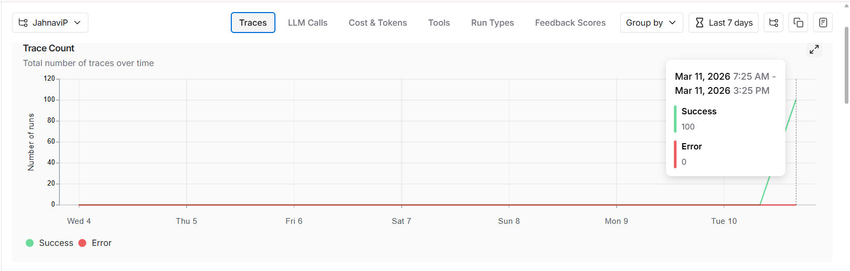

Trace Latency and Error Rate
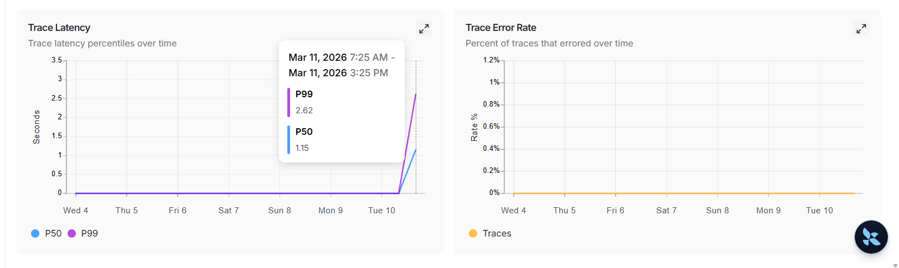

LLM Latency
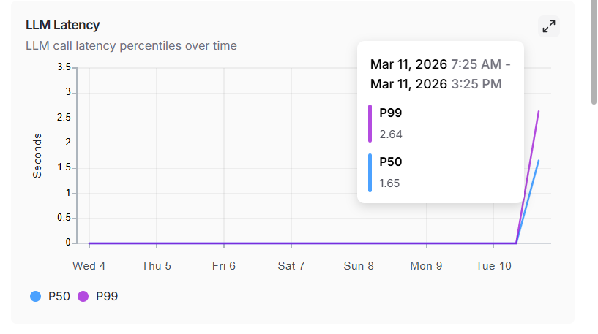
LLM Count
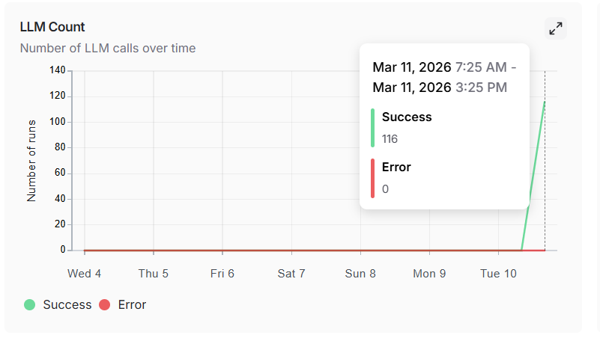

Cost Tokens
